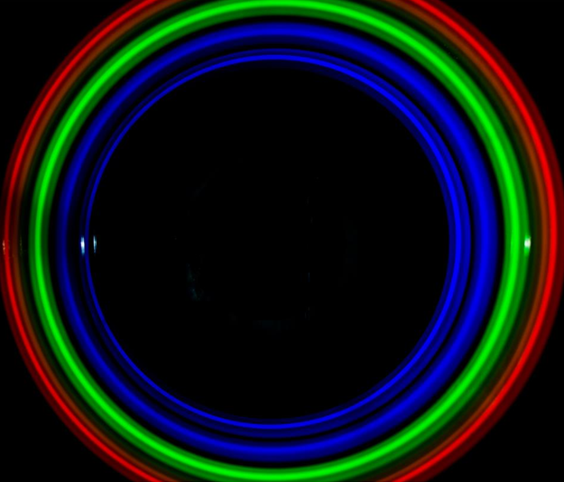
8th
SU2P
Symposium
5th & 6th April 2017
Heriot Watt
University

SU2P Symposium Sponsorship Packages
For the 8th year in a row SU2P is aiming to keep the symposium fees at a minimum level and continue to offer excellent value to all participants. In 2017 SU2P is therefore offering sponsorship packages which may be split or shared between parties who wish to support the event and also benefit from the additional value that comes from being a sponsor.
Why sponsor?
- Highlight and raise awareness of your organisation to the Scotland-Stanford Photonics Community
- Reach>200 delegates ranging from students to senior research scientists and industrialists working in photonics in Scotland, the USA and internationally
- Have your organisation logo/weblink featured on the SU2P website and during the event
- Provide information and materials for distribution to delegates
- Support student involvement in the SU2P symposium
- Access the facilitation services of SU2P

The following sponsorship packages are offered and may be shared across sponsors wishing to contribute amounts from a minimum of £100
- £100 – Poster Prize
- £150 – Student Presentation Prize
- £250 – Sponsor a session (Healthcare & Medicine; Energy & Environment; Communications & IT; Advanced Manufacturing; Defence & Security and the Student Presentations )
- £300 – Refreshment Breaks (5)
- £400 – Poster Session & Drinks Reception
- £750 – Lunches (2)
- £1000 - Wine for Symposium Banquet
- £1500 – Symposium Banquet

Please contact SU2P Project Director Carol Scullion to carol.scullion@strath.ac.uk or 07802 792903
For further information on the 8th SU2P Annual Symposium please go to www.su2p.com

